Smart Interview Preparation Portal with Integrated AI and Live Code Execution

Literature Review
TITLE & AUTHORS | METHODOLOGY (DATA FORMAT) | PROPOSED SYSTEM | CON’s (LIMITATIONS) | CONCLUSION
Traditional Interview Preparation Methods (Author et al.) | Printed materials, PDFs, static question banks | Conventional preparation using books, notes, and static online resources for interview preparation | No practical coding evaluation, lack of interaction, no personalized guidance | Highlighted the need for interactive and practice-oriented interview preparation systems
Online Interview Preparation Platforms (Author et al.) | Web-based question repositories, user profiles | Web portals providing interview questions and explanations without live execution support | No real-time code execution, limited assessment of coding skills | Improved accessibility but failed to simulate real interview environments
Online Coding Practice Platforms (Author et al.) | Source code submissions, test case results, execution logs | Platforms allowing users to write and submit code for evaluation against test cases | Generic problem recommendations, no interview-focused learning path | Enabled hands-on coding practice but lacked interview-specific personalization
AI-Based Personalized Learning Systems (Author et al.) | User performance data, learning history, analytics logs | AI-driven systems recommending content based on user performance and behavior | Requires large datasets, limited real-time coding integration | AI improves personalization but needs integration with practical coding environments
Cloud-Based Code Execution Services (Author et al.) | Source code, programming language metadata, execution output | Remote code compilation and execution using cloud APIs such as JDoodle | Dependency on third-party APIs, internet dependency | Cloud execution enables multi-language support and scalability
Integrated Interview Preparation Systems (Author et al.) | User profiles, coding attempts, assessment scores | Platforms combining interview questions, coding practice, and progress tracking | Limited AI intelligence, partial automation | Integration improves user experience but requires AI and live execution
Secure Web Applications for Learning Platforms (Author et al.) | Authentication logs, encrypted credentials | Secure login systems using role-based access and encrypted authentication | Slight increase in system complexity | Security mechanisms enhance trust and data protection
AI-Powered Interview Preparation Portals (Author et al.) | User interaction data, coding performance metrics | AI-powered portals offering personalized preparation paths and coding evaluation | Accuracy depends on data quality | AI-driven portals significantly enhance interview readiness

Detailed Requirement Analysis
Functional Requirements
1. User Authentication and Authorization
- Role-based login for Admin and Users (Candidates)
- Secure user registration and login using email and password
- Session management for authenticated users
- Role-based access control to restrict administrative features
- Secure logout functionality
2. Interview Content Management
- Admin can create, update, and delete interview questions
- Categorization of questions based on topic, difficulty, and technology
- Support for technical and coding-based interview questions
- Version control for interview questions
3. AI-Based Personalized Preparation
- AI-driven analysis of user performance
- Personalized question and topic recommendations
- Adaptive difficulty level based on user progress
- Learning path generation for interview readiness
4. Live Code Execution System
- Integrated real-time code execution using JDoodle API
- Support for multiple programming languages
- Execution of user-written code with custom input
- Display of output, compilation errors, and runtime errors
- Secure handling of execution requests and responses
5. Code Submission and History Tracking
- Storage of user code submissions
- Tracking of execution results and timestamps
- Ability for users to review previous submissions
- Performance tracking based on code execution outcomes
6. Data Retrieval and APIs
- Asynchronous data fetching using JSON responses
- RESTful APIs for user data, questions, submissions, and results
- Secure API endpoints with authentication validation
- Integration with external APIs (JDoodle)
7. Reporting and Progress Analytics
- User dashboard showing preparation progress
- Topic-wise and difficulty-wise performance analysis
- Admin dashboard for monitoring user engagement
- Visualization of learning progress and statistics
Non-Functional Requirements
- Security:
Encrypted user credentials, secure session handling, role-based access control, and secure API communication.
- Scalability:
Modular Spring Boot architecture capable of handling multiple users and concurrent code execution requests.
- Performance:
Optimized database queries using JPA/Hibernate, asynchronous API calls, and efficient request handling.
- Usability:
Responsive user interface using HTML and CSS, intuitive dashboards, and easy navigation.
- Reliability:
Consistent system availability, accurate execution results, reliable third-party API integration, and data integrity.
System Architecture:
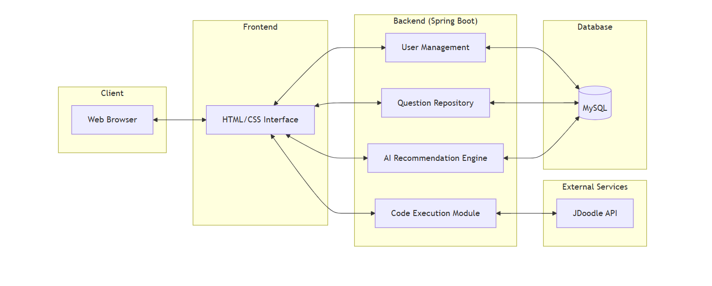

Flow chart:

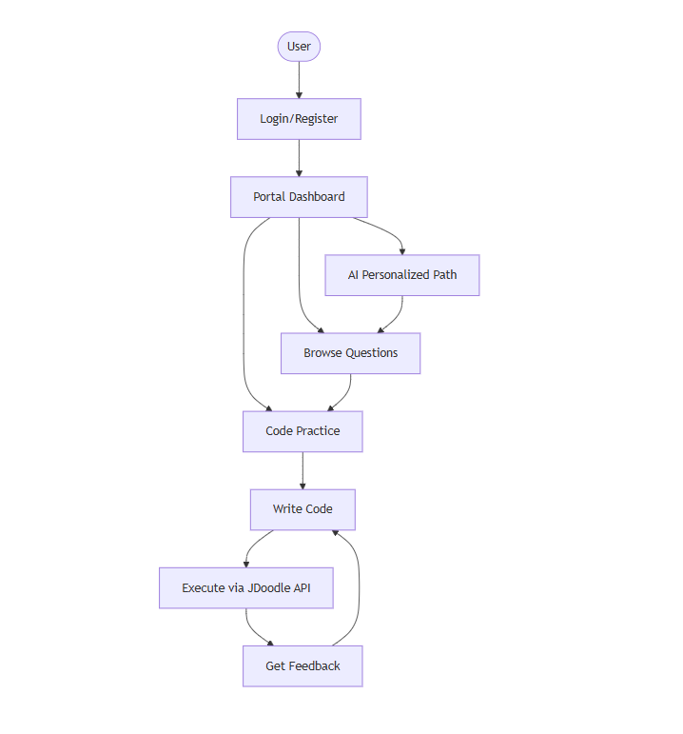

Class diagram:
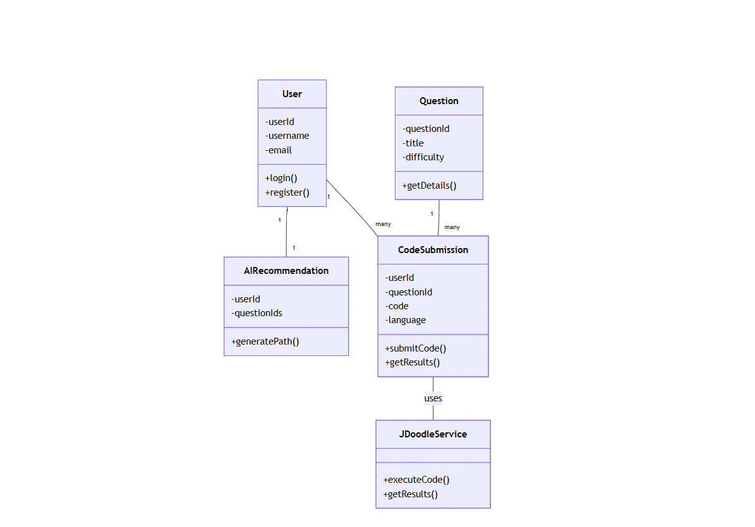

Modules in Detail

1. Authentication and Authorization Module

Secure user registration and login using email and password

Role-based authentication for Admin and Users (Candidates)

Session management to maintain authenticated user state

Access control to restrict administrative functionalities

Secure logout mechanism to terminate sessions safely

2. User Management Module

Admin-controlled creation, update, and deletion of user accounts

Role assignment and management (Admin, User)

User profile management including personal details and preferences

Tracking of user activity and preparation progress

3. Interview Question Management Module

Admin functionality to add, edit, and delete interview questions

Classification of questions by topic, difficulty level, and technology

Support for both theoretical and coding-based questions

Question versioning and content management

4. AI-Based Recommendation Module

Analysis of user performance and activity data

Personalized interview preparation recommendations

Adaptive learning paths based on strengths and weaknesses

Dynamic difficulty adjustment for practice questions

5. Live Code Execution Module

Integration with JDoodle API for real-time code compilation and execution

Multi-language programming support

Execution of user code with custom input handling

Display of execution output, compilation errors, and runtime errors

Secure communication with external execution services

6. Code Submission and History Module

Storage of user code submissions and execution results

Timestamped history of coding attempts

Review and comparison of previous submissions

Performance analysis based on execution outcomes

7. Reporting and Dashboard Module

User dashboard displaying preparation progress and performance

Topic-wise and difficulty-wise performance analytics

Admin dashboard for monitoring overall platform usage

Graphical representation of user progress and trends

8. Security Module

Encrypted storage of user credentials

Secure session handling and timeout management

Validation of API requests and responses

Protection against unauthorized access and misuse

